Genre - formal-thematic type of text which serves as a basic criteria of discerning particular units and complex pieces. The following genres have been defined:
- anecdotal biblical [bib] - a narrative which reiterates or explains a biblical account, most often with the intrusion of some entity to the story;
- anecdotal rabbinic[rab] - a narrative which concerns the personal rabbinic encounters with the demons;
- cultic protocol [cult] - concerns the ritual issues (such as actions, paraphernalia and appurtenances) which involve the entities and most often deals with necromancy and idolatry; it also contains a separate group of exclusive references to Azazel;
- pragmatic advice [prag] - covers all the down-to-earth details concerning the relationships between humans and demons and boils down to the specific dos and don’ts such as do not wander alone and devoid of any source of light at night or do not sleep alone in an empty house;
- proverb [prov] - applies the name of a particular entity in what appears to be a kind of a proverb, folk wisdom, euphemism, simile or any other conventional manner of speech, e.g. "do not open your mouth for Satan", "Satan dances between ones horns" or "the daughter of Belial";
- statement [stat] - presents some general traits of a given entity and although the examples can be quite complex in terms of their contents and involve a detailed visual description or a flamboyant simile, they take a form of simple statements or assertions.
Obviously and as is common on the grounds of the broadly understood humanities, the classification of particular passage to a given genre is at least to some extent arbitrary. Yet, in order to reduce the bias and secure a certain level of consistency the following classification heuristic has been resorted to throughout the project:
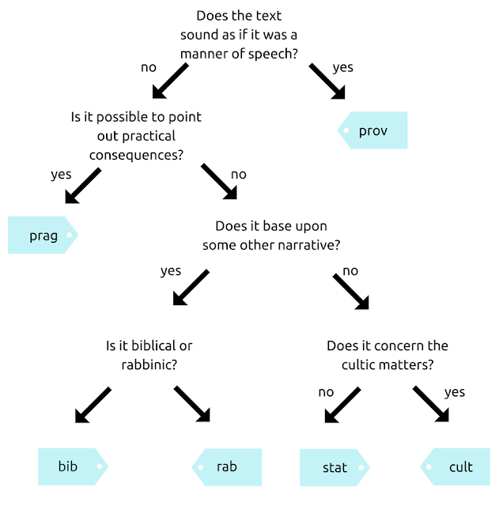
Unit - isolated part of text which is coherent in regards with its genre and at the same time remains as large as possible to accommodate this coherence. One unit occupies one verse in the database and is the basic measurement-unit.
Piece - thematically coherent fragment composed of two or more units. In the database the units constituting a piece are marked in a hue of blue.

